**รอยต่อและจุดเชื่อมต่อในงานโครงสร้างเหล็ก**

รูปภาพที่ 2

..................................................................................................................................................................................................................................................................................................................................................................................................................................................................................................................................................................................................................................................................................................................................................................

รูปภาพที่ 1

..................................................................................................................................................................................................................................................................................................................................................................................................................................................................................................................................................................................................................................................................................................................................................................

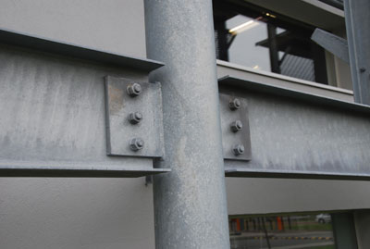

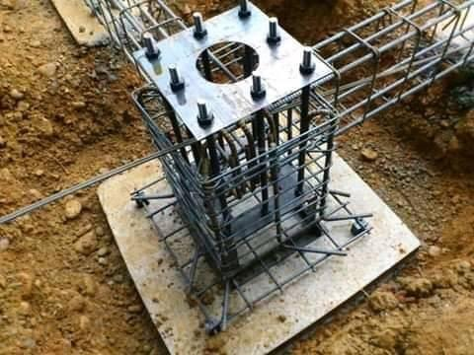

ภาพที่ 1

ภาพที่ 2

**ชื่อ………………………………………………**

**รหัสนักศึกษา.......................................**

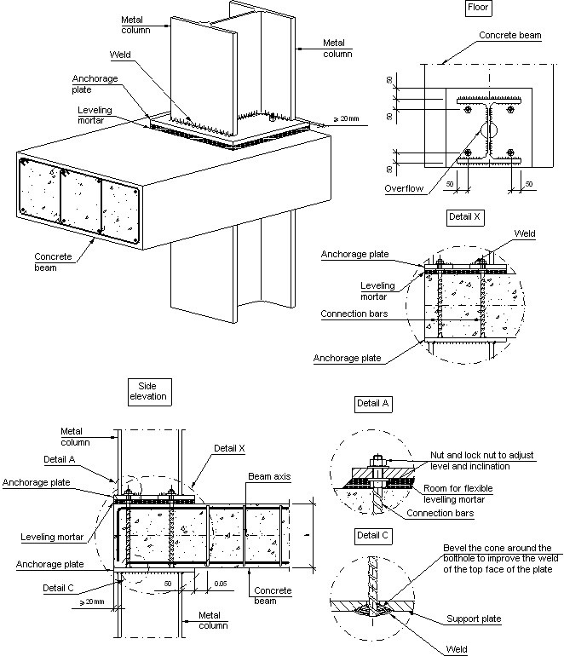

ภาพแบบแปลน

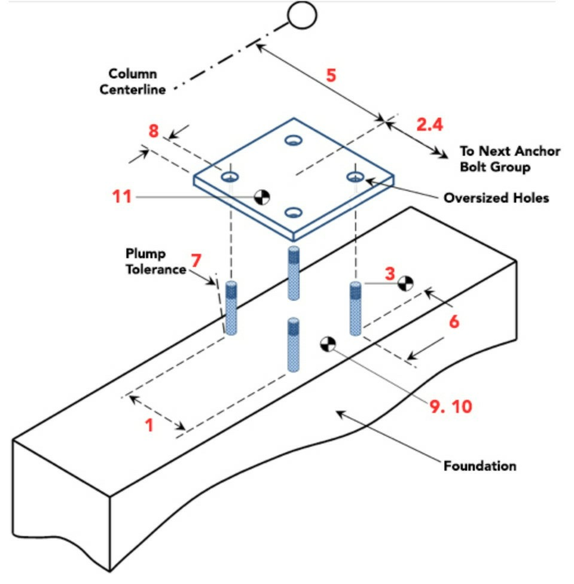

ภาพ Isometric